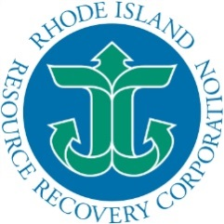
RHODE ISLAND
Department of Environmental Management
Office of Waste Management
235 Promenade Street, Room 380
Providence, Rhode Island 02908

August 23, 2018

2019 Brand Allotment Assignments

The Rhode Island Department of Environmental Management (RIDEM) together with the Rhode Island Resource Corporation (RIRRC) have finalized all computer equipment return share and television market shares. The final allotments by weight can be found at http://rirrc.org/questions/e-waste/ by downloading the ‘2019 Manufacturer’s Shares – FINAL’ file.

The shares were calculated and approved pursuant to Rhode Island Electronic Waste Prevention, Reuse and Recycling Act (R.I. General Law 23-24.10) http://webserver.rilin.state.ri.us/Statutes/TITLE23/23-24.10/INDEX.HTM . The Rhode Island statewide recycling target for 2019 is based on 5.5 pounds per person and the 2017 census population of 1,059,639 persons. The total target of 5,828,015 pounds is allocated between computer equipment (11.25%) and televisions (88.75%) based on the percentages from the state-run program for quantities collected in 2017. Likewise, the computer equipment brand returns were obtained from a 100% brand sample of the state-run collection program during 2017 and used to allocate computer returns share among brands. While the television market-share data for the 12 months ending December 31, 2017, obtained from the Electronics Recycling Coordination Clearinghouse, was utilized to allocate television collection shares.

RIRRC has requested that the state-run program cost per pound be billed at $0.30 per pound in 2019.

Legislative Changes

A bill to revise the Rhode Island Electronic Waste Prevention, Reuse and Recycling Act has been signed into law:

- The date for registration and plan submittal has been moved up from December 15th to October 15th under the new law.

- Beginning with calendar year 2017, manufactures may carry over a credit (or deficit) of 10% of their allotment to the following year. If you collect an amount under 90% of your allotment, you will be required to purchase the difference between your amount and 90% of the allotment from the State at a rate of $0.33/lb. Anything above 10% over your allotment is forfeit or may be sold to another collector. All sales must be documented on a template provided by the Department or they will not be counted.

- Manufacturers with less than 5% of the Market or Return Share will automatically be assigned to the State Program.

- Quarterly reporting on a template provided by the DEM is mandatory unless you are in the State Program.

If you have any questions or comments regarding this notice or the basis of the share calculations, contact RIRRC, Dean Huff at 401-942-1430 or by email at dhuff@rirrc.org. If you have questions regarding the Rhode Island Electronics Waste Prevention, Re-Use and Recycling Act, the registration process, or creating a recycling plan, please contact RI DEM, Alyson Brunelli at 401 222-2797, or via email at alyson.brunelli@dem.ri.gov.

Best Regards, Sincerely,

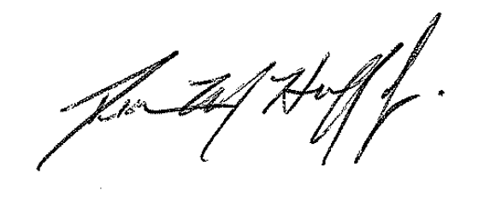
Alyson Brunelli, Engineer Dean Huff, Chief Financial Officer
RI DEM RIRRC

